Oil Price Dynamics and Volatility Analysis: A Statistical Study of Brent and WTI Crude Oil (2000–2026)

1. Project Overview
This study analysed Brent crude and WTI oil spot prices from 2000 to 2026, setting out to discover how susceptible oil prices are to conflicts and more broadly to study their volatility and derive a model that could accurately learn and predict future prices.
The data of all oil grades were extracted from the EIA API and loaded into a Pandas DataFrame for analysis. The Pandas library was used to structure and clean the data. The correlation between the oil grades was calculated and propane had the lowest correlation with all other grades. WTI and Brent oil were selected as the focus of this analysis. A line plot was used to show price movement over the years, and the series was further decomposed to show the underlying trend without the influence of noise or seasonality. Rolling volatility and the Brent-WTI price spread were also examined to understand market stability and price divergence between the two grades over time. The Augmented Dickey-Fuller (ADF) test was applied to determine whether the data was stationary and to identify the suitable model. Brent oil was not stationary while WTI was stationary. This led to differencing the Brent oil values to make them suitable for the ARIMA model. The ACF and PACF plots were used to determine the specific parameters p, q and d. The ACF and PACF revealed that WTI was not stationary despite the result from the ADF test. The led to the differencing of WTI prices.
On application to the ARIMA model, the model could not adequately generalise and adapt to historical shocks. This led to the use of GARCH, GJR-GARCH and EGARCH models, which revealed key insights into the asymmetric response to price shocks and volatility persistence.
2. EDA Findings
The oil price was fluctuating between $15–$40 from 2000 till October 2003, it then started to rise steadily from this point with minor corrections along the way before reaching its peak at the beginning of the stock market crash (Brent $132.32 and WTI $133.57) due to the combination of surging Chinese and Indian demand, the weak US dollar, and speculative investment in oil futures and then fell rapidly to a price close to the pre-2003 price range before picking up again due to conflicts in the middle east with prices peaking (Brent $123.26 and WTI $109.53) in April 2011 at the peak of the Arab Spring. The largest spread ($27.3) was recorded during this conflict in September 2011 because the US was able to increase their supply through the discovery of shale oil, hence reducing the impact of the supply disruption in the middle east on their prices. After a period of relative stability, prices started to drop as OPEC made concerted efforts to bring down the price of their exports to compete with the new American shale oil. The price of oil dipped to as low as $30–$32 in 2016. This price continued to fluctuate between $44–$82 for the next 5 years before the announcement of the lockdown which had a negative effect on prices, forcing it to dip to $16–$18 in April 2020. It began to increase as some of the coronavirus restrictions started to be relaxed and firms developed management strategies to function during the lockdown, increasing to $114–$123 during the Ukraine war. The price gradually declined amid the conflict in Ukraine, dropping to the $55–$65 range in December 2025. Recently, a steep rise has been observed in the price of crude oil as the war with Iran intensifies and an important supply route (Strait of Hormuz) is blocked from non-Iranian shipments.

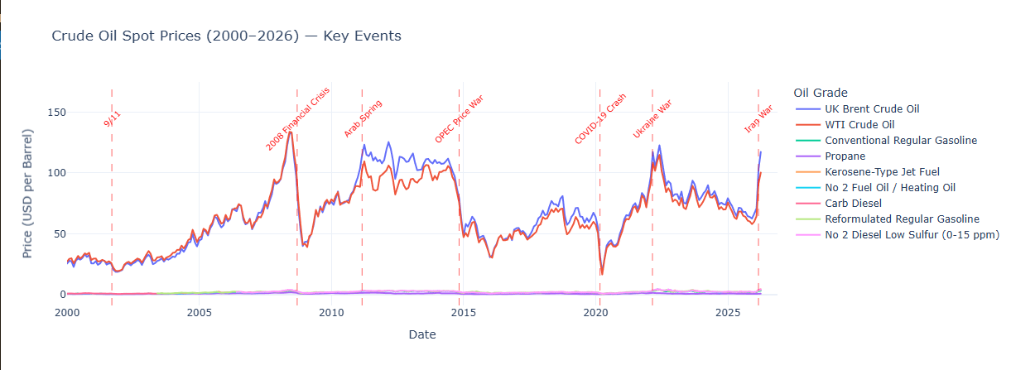

The rolling volatility analysis confirmed that 2008 financial crisis generated the highest 12-month volatility spike across the entire 26 year period, higher than the COVID in 2020.

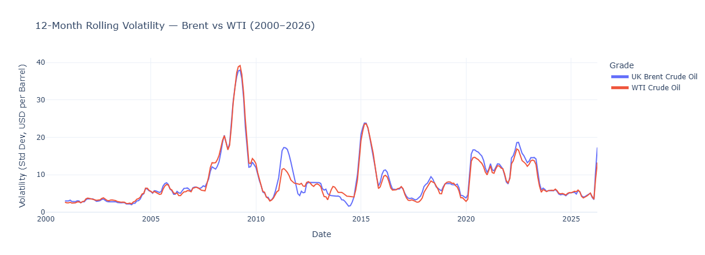
Per the Brent–WTI spread chart, the difference between the two products was within the range of ±$5 with the per barrel cost of WTI being higher than Brent oil for most of 2000–2010 before expanding during the conflict in the middle east in 2011. Brent oil continued to sell for more than WTI for the majority of 2011–2026, with a notable spike in the spread observed in early 2026 coinciding with the Iran war and UAE OPEC exit.
From the correlation analysis, Propane is an outlier. This is because it is a byproduct that can be obtained from non-crude oil sources like natural gas.
The seasonal component showed a consistent annual cycle with oil prices typically lower in summer and peaking in winter, with a modest swing of ±4–6%. The residual component, however, revealed unexplained shocks of far greater magnitude, particularly during the 2008 crisis and COVID crash.

3. Statistical Testing Findings
The Brent oil and WTI data was tested to determine if they are stationary using the Augmented Dickey-Fuller (ADF) test. The test used an industry standard significance level of 5% with the hypothesis:
Null hypothesis H₀ : Non-stationary
Alternate hypothesis H_{A}: Stationary
The resulting p -value for Brent oil was 0.0845 while that of WTI was 0.0377, this meant that we failed to reject the null hypothesis for the Brent oil confirming non-stationarity and rejected the null hypothesis for WTI confirming stationarity. The result obtained from the ADF test for the WTI was unexpected given that oil prices are generally considered non-stationary in literature. The Brent oil being non-stationary was not suitable for the ARIMA model which required differencing to make it stationary using the python pandas library method “.diff()” and then an ADF test to confirm if it is stationary. The Autocorrelation Function (ACF) and Partial Autocorrelation Function (PACF) charts were plotted using the statsmodels library to determine the appropriate value for parameters p, q and d. The ACF plot revealed that the WTI model which appeared stationary from the ADF test was not stationary and that the differenced Brent value showed significant lag 1 in both ACF suggesting ARIMA(1,1,1) where p=1, d=1 and q=1 representing the autoregressive, differencing and moving average terms respectively. For the ARIMA model the Brent oil value was used because unlike the WTI value it showed the global geopolitical effect more prominently.

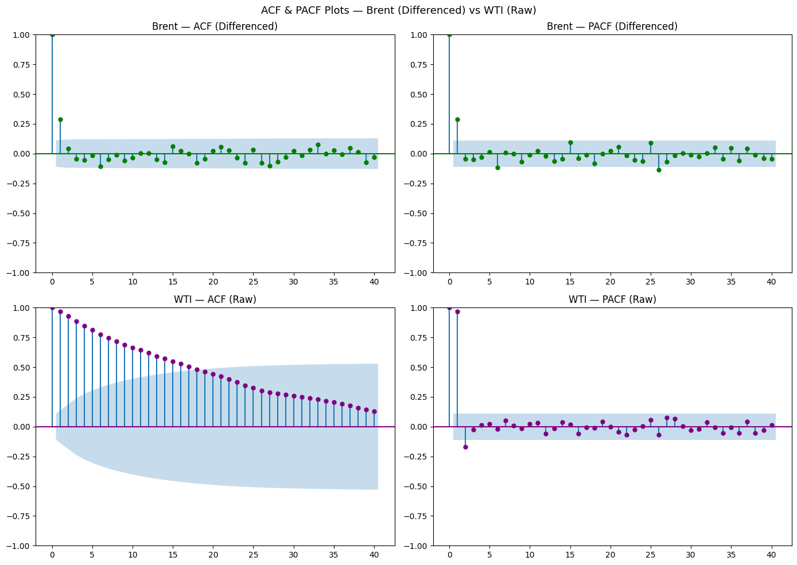
4. ARIMA Findings
The ARIMA model forecasted $115 over 12 months with a wide confidence interval which widens into the future, suggesting increasing uncertainty the further the forecast extends, thus indicating the presence of high variability in the prediction. From the ARIMA model summary the p-value for the AR term was 0.106, which indicates that it was not significant. This means that last month's price does not predict this month's price. This indicates that the relationship between consecutive months is weak and could just be random noise.
The p-value of the MA term was 0.359, which indicates that it is not significant. This means that last month's errors did not influence this month's price, meaning past forecast errors do not help correct future predictions. This indicates that the price direction is largely unpredictable when using this model.
The heteroskedasticity value from the variance break test was 1.92, which indicates that the variance is increasing over time and the errors at the later part of the data are much larger and more volatile than they were at the beginning.
The Ljung-Box test, used to determine if the residuals from a model are just noise or contain unexplained patterns, returned a statistic of 0.00 and a p-value of 0.98, indicating no evidence of autocorrelation in the residuals.
The Jarque-Bera (JB) test, used to determine the normality of the model's residuals, returned a statistic of 131.11, indicating that the residuals failed the normality test and deviate significantly from the standard bell-shaped normal curve.
The AIC score was 2016.348 and the BIC score was 2027.594. These two scores will serve as a baseline for comparison with the GARCH models fitted subsequently. It should be noted that the ARIMA and GARCH AIC scores are not directly comparable as they model different aspects of the data.
Together the heteroskedasticity and non-normal residuals confirmed that ARIMA was insufficient and justified the use of GARCH models, which are specifically designed to handle changing variance and fat tails.

5. GARCH Modelling Findings
GARCH is a model that uses past information to estimate current uncertainty and forecast future volatility. This model was used because it is best suited for heteroskedastic time series. The alpha is the shock sensitivity term that measures how sensitive next month's expected volatility is to recent market surprises or news. The value was 0.4252, which indicates that 42.52% of any squared price shock from the current month directly feeds into next month's volatility forecast. The beta component is the volatility persistence term that measures how much of last month's volatility state will carry over to define next month's volatility. The beta term was 0.000 with a p-value of 1.000, which means that oil prices have zero long term volatility memory, meaning each new shock is treated as an isolated event rather than part of a sustained volatile period. By running GJR-GARCH, the oil prices were tested to determine if the high alpha was being skewed heavily by negative shocks.
The AIC and BIC scores are 2257.74 and 2280.21 respectively, which will serve as the baseline for the subsequent GARCH models.
In the GJR-GARCH model the alpha dropped significantly from 0.4252 to 0.0856, confirming that the high alpha in the standard GARCH model was indeed being inflated by negative shocks which GJR-GARCH correctly separated out. The beta score remained approximately zero at 7.1214e-18, confirming that oil prices have no continuous volatility persistence and that previous general turbulence has zero mechanical carrying power into the next month. The gamma value of 0.5673 means that negative shocks generate approximately 7.6 times more volatility than equivalent positive shocks, confirming a strong asymmetric response to bad news in oil markets. Oil prices react more violently to bad news, driven by market panic. The p-value of gamma being 0.004 confirms with 99.6% confidence that this asymmetric effect is real and not a statistical fluke. The AIC and BIC scores are 2252.05 and 2278.28 respectively, which is a slight improvement on the standard GARCH model.
The Exponential GARCH (EGARCH) model was fitted as a final comparison. Unlike standard GARCH, EGARCH models the logarithm of variance rather than variance directly, making it more robust to extreme outliers like the COVID crash. EGARCH captures this asymmetry by letting negative returns have a different impact on future volatility than positive returns of the same magnitude. The alpha value of 0.6089 was strongly significant at p=0.000, confirming that new shocks have a strong immediate impact on volatility. Unlike GARCH and GJR-GARCH where the beta was approximately zero, EGARCH revealed a beta of 0.75, which indicates that 75% of last month’s volatility carries forward into next month. The AIC of 2255.26 and BIC of 2277.74 represent an improvement over the standard GARCH model but are slightly higher than GJR-GARCH on AIC while marginally better on BIC.
Comparing all three models, GJR-GARCH achieved the lowest AIC of 2252.05 while EGARCH achieved the lowest BIC of 2277.74. EGARCH is recommended as the preferred model overall because it was the only model that correctly identified volatility persistence through a significant beta of 0.75, which aligns with the visual evidence from the rolling volatility chart and established oil market behaviour. GJR-GARCH remains valuable for its gamma findings which quantified the asymmetric response to negative shocks.

6. Limitations
The ARIMA and GARCH models are purely statistical and do not have geopolitical knowledge, which is a strong limiting factor as geopolitics influences price movements greatly as seen in the decomposition chart.
The models cannot predict black swan events like COVID-19, which can cause the model to significantly underestimate future volatility during unprecedented events.
The models do not incorporate external variables such as US dollar strength, global GDP growth, OPEC production levels or inventory data, all of which are known drivers of oil price volatility.
The standard GARCH and GJR-GARCH models produced a beta of approximately zero, which is economically implausible and suggests these models struggled to fully capture the volatility dynamics of oil prices despite EGARCH resolving this issue.
The GARCH modelling was conducted exclusively on Brent crude oil returns. Extending the analysis to WTI and other grades may reveal different volatility dynamics.
The data represents monthly spot prices, consequently missing intraday and weekly volatility spikes that may be significant during crisis periods.
The analysis covers 2000–2026 and may not fully capture structural changes in the oil market such as the energy transition toward renewables which could fundamentally alter future price dynamics.

7. Real World Implications
Petrostates like Nigeria heavily depend on revenues from oil to fund public infrastructure, social programs and public sector wages. These models help finance ministries in budget planning by setting realistic benchmark oil prices in their budgets, helping to prevent fiscal deficits.
Oil and gas companies require massive capital expenditure to drill new wells or build offshore platforms; these models help to determine if a multi-million-dollar project will be profitable over their lifespan.
Oil as an energy source is instrumental in manufacturing and other aspects of life which makes its prices act as a primary driver of inflation of everything from groceries to electricity. These models can help central banks to preemptively adjust interest rates to protect consumers’ purchasing power.
In the context of the ongoing Iran war and the UAE's exit from OPEC, these models are particularly relevant as they signal a period of elevated volatility, urging both governments and corporations to adopt more conservative financial planning assumptions.

8. Conclusion

The analysis shows that geopolitical events remain the dominant driver of oil price movements. While seasonal patterns were present in the data, their effect was relatively small compared to the impact of major supply disruptions, financial crises and armed conflicts.

The statistical tests produced an interesting result. Brent crude oil behaved as expected for a commodity price series and was found to be non-stationary prior to differencing. WTI, however, passed the ADF test despite exhibiting characteristics commonly associated with non-stationary series. This highlights an important limitation of relying on a single statistical test when analysing time series data.
The ARIMA model was able to capture the broad direction of the series but struggled with changing volatility. This was evident from the heteroskedastic residuals and the failure of the residuals to satisfy normality assumptions. Since oil markets are characterised by periods of calm followed by sudden bursts of volatility, a volatility-based approach was more appropriate.
Among the models tested, EGARCH provided the most realistic representation of oil market behaviour. Unlike the standard GARCH specification, it identified substantial volatility persistence, suggesting that periods of uncertainty tend to carry forward rather than disappear immediately. The GJR-GARCH model also revealed a strong asymmetry in the response to shocks, showing that negative events generate significantly more volatility than positive events of a similar magnitude.

My final thoughts
The results suggest that oil markets react far more strongly to bad news than good news and that the effects of major shocks can persist long after the initial event. For governments, energy companies and investors, this reinforces the importance of treating volatility itself as a risk factor rather than focusing solely on the direction of prices.
Recent geopolitical tensions in the Middle East have contributed to heightened uncertainty in oil markets. However, this has caused the affected nations to speed up the construction and expansion of alternate routes which, with time, may see at least a stabilisation at current prices or at best a decrease as supply meets demand. The UAE's exit from OPEC was driven by the restrictive production quotas which had been limiting them from maximising their oil revenue. This exit means they are no longer bound by these quotas and can ramp up production from the capped 3.2–3.5 million to 4.85 million barrels per day, adding approximately 1.35 million barrels per day to global supply. While this is expected to exert downward pressure on prices, the overall impact may be moderate given the current elevated prices driven by the ongoing Iran war.

